**Project Design Phase-II**

**Data Flow Diagram & User Stories**

| Date | 26-05-2025 |
| --- | --- |
| Team ID | LTVIP2025TMID58962 |
| Project Name | DocSpot: Seamless appointment Booking for Health |
| Maximum Marks | 4 Marks |

**Data Flow Diagrams:**

A **Data Flow Diagram (DFD)** illustrates how data moves within the Freelance Finder platform. It captures how users (freelancers and clients) interact with the system, how information flows between different components, and where the data is stored.

**Example: DFD Level 0 (Industry Standard**)

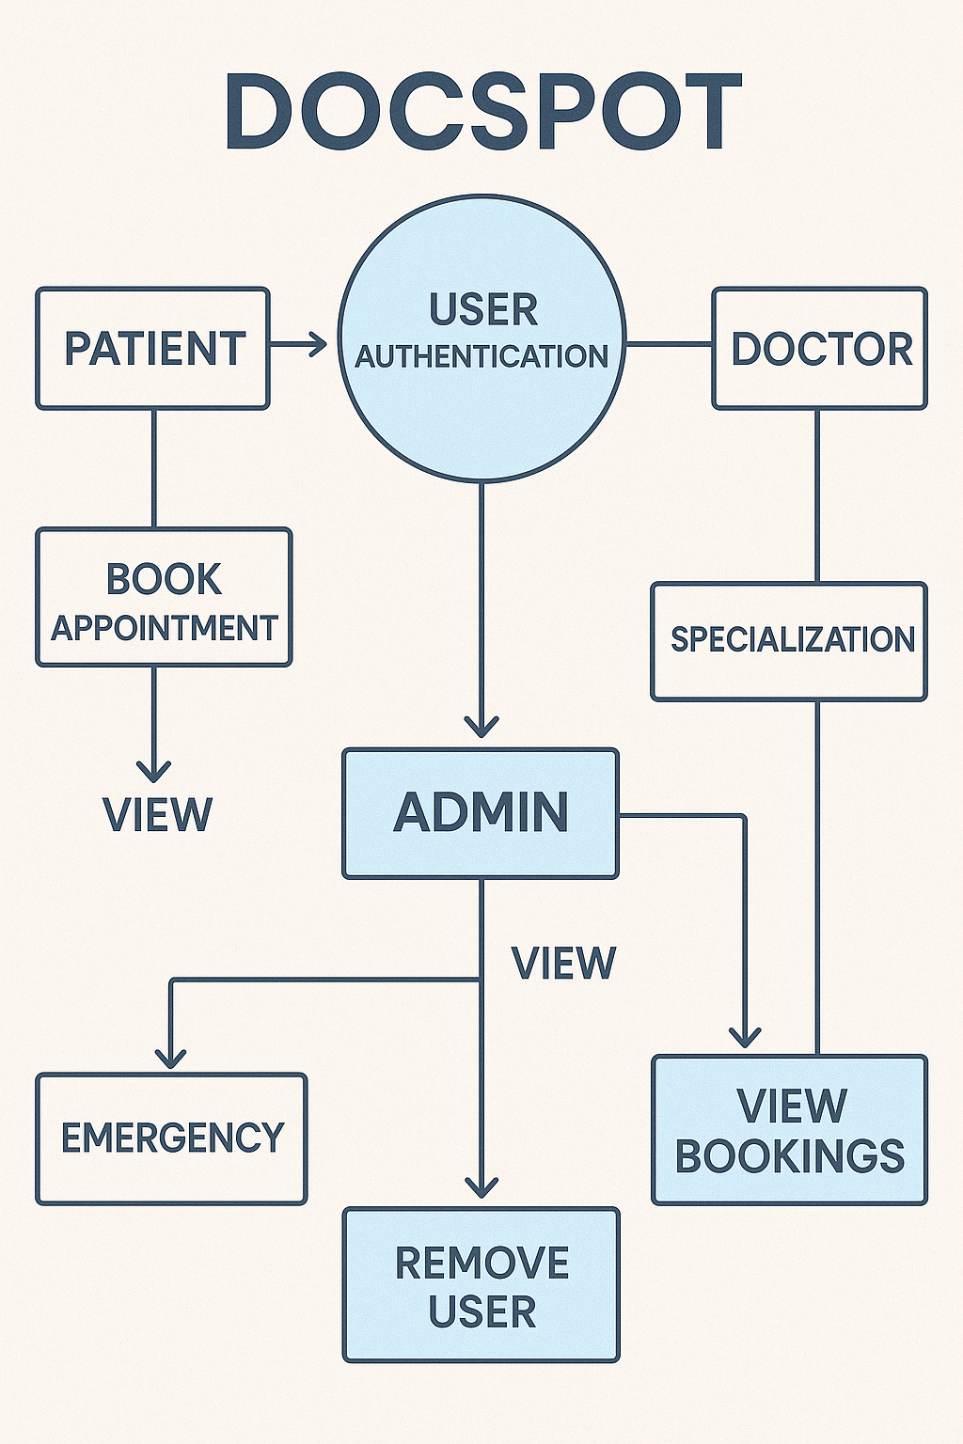

**User Stories**

**User Story Table – DocSpot**

| **User Type** | **Functional Requirement (Epic)** | **User Story / Task** | **Acceptance Criteria** | **Priority** | **Release** |
| --- | --- | --- | --- | --- | --- |
| | **Patient** | | --- |  |  | | --- | | | Appointment Booking | | --- | | As a patient, I can search for doctors by specialty and location. | Search results return relevant doctors. | High | Sprint-1 |
|  |  | As a patient, I can book, reschedule, or cancel appointments. | | Appointment status updates accordingly. | | --- |  |  | | --- | | Medium | Sprint-2 |
| | **Healthcare Provider** | | --- |  |  | | --- | | | Schedule Management | | --- |  |  | | --- | | | | As a provider, I can manage my availability calendar. | | --- |  |  | | --- | | | --- | --- | --- | | | Changes reflect immediately in patient booking system. | | --- |  |  | | --- | | High | Sprint-1 |
| **User** | Messaging | As a user, I can chat with the other party in real-time. | Messages appear instantly. | Medium | Sprint-2 |
| **Admin** | Profile Management | As a Admin, I can update my profile. | Changes are saved successfully. | High | Sprint-2 |
| **Client** | Payment Processing | As a client, I can make secure payments after job completion. | Payment recorded and shown in transaction history. | High | Sprint-2 |
| **user** | |  | | --- |  | Review System | | --- | | As a user, I can leave a review after project closure. | Review appears on profile. | Medium | Sprint-2 |
| **Admin** | User Moderation | As an admin, I can review reported users and take action. | Reports and actions logged. | High | Sprint-1 |

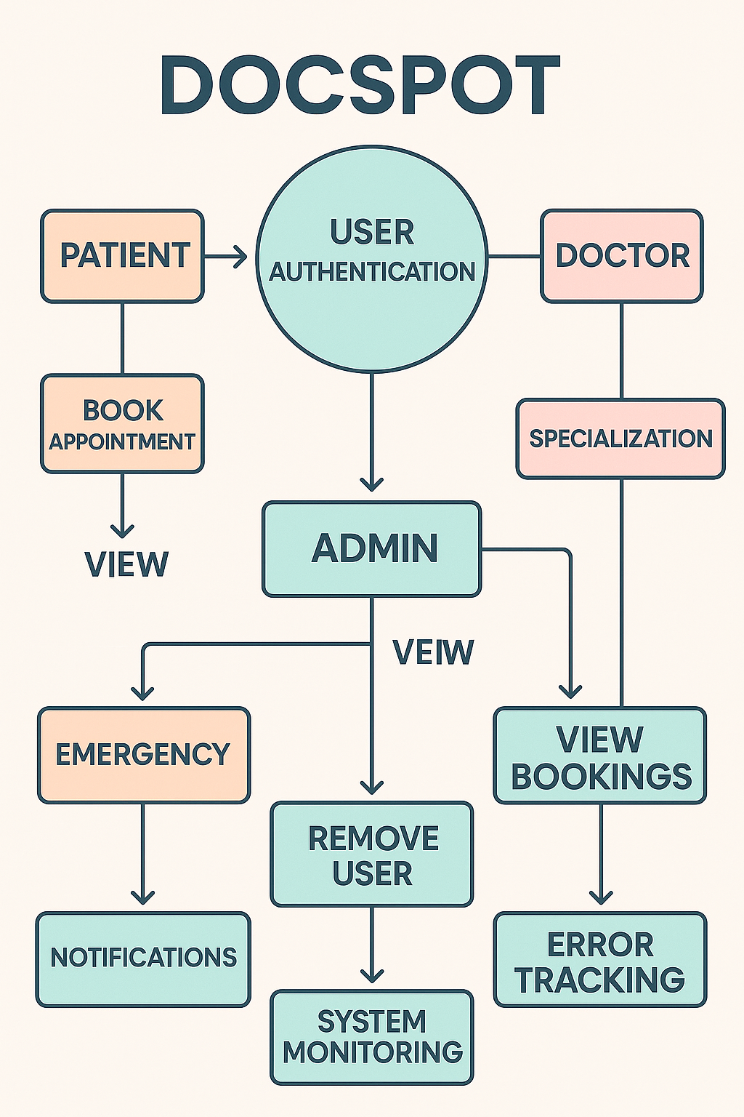

**Data Flow Diagram (Level 0)**

This Level 0 DFD represents the high-level interactions between users and major subsystems of DocSpot, with a new structure and more detailed process flows.

**External Entities (Actors)**:

* Patient
* Healthcare Provider
* User (Generic: includes patient, client, etc.)
* Admin
* Client

**Processes:**

1. Appointment Booking System

2. Schedule Management

3. Review and Messaging System

4. Profile & User Moderation System

5. Payment & Transaction System

**Data Stores:**

* D1: Doctor Directory
* D2: Schedule DB
* D3: Message Log
* D4: User Data Store
* D5: Payment Records
* **Data Flow Description**:
* The Patient interacts with the Appointment Booking System, providing search queries and booking details. The system pulls doctor data from Doctor Directory (D1).
* The Healthcare Provider updates availability through the Schedule Management process, which stores availability in Schedule DB (D2).
* Users can chat and leave reviews via the Review and Messaging System, which stores data in Message Log (D3).
* Admin can update profiles and moderate users via the Profile & Moderation System, updating User Data Store (D4)
* Clients perform payments via the Payment System, which records transactions in Payment Records (D5).

**User Stories Summary**

**1. Patient**

* **Search and Book Appointments**

As a patient, I can search for doctors by specialty and location.

Acceptance: Relevant doctors appear.

Priority: High (Sprint-1)

* **Manage Appointments**

As a patient, I can book, reschedule, or cancel appointments

Acceptance: Status updates reflect properly.

Priority: Medium (Sprint-2)

**2. Healthcare Provider**

* **Calendar Management**

As a provider, I can manage my availability calendar.

Acceptance: Changes reflect in the booking system immediately.

Priority: High (Sprint-1)

**3. User (General)**

* **Messaging**

As a user, I can chat with the other party in real-time

Acceptance: Messages appear instantly.

Priority: Medium (Sprint-2)

* **Review System**

As a user, I can leave a review after project closure.

Acceptance: Review is displayed on the profile.

Priority: Medium (Sprint -2)

**4. Admin**

* **Profile Management**

As an admin, I can update my profile.

Acceptance: Changes are saved successfully.

* **User Moderation**

As an admin, I can review reported users and take action.

Acceptance: Reports and actions are logged.

Priority: High (Sprint-1)

**5. Client**

* **Payment Processing**

As a client, I can make secure payments after job completion.

Acceptance: Payment is recorded and shown in history.